Creating user id In Kerberos environment

1. Create user id in all the nodes

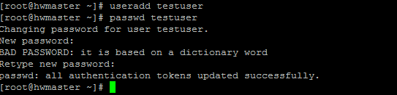

NOTE:

Password: testuser

Create user id in all nodes

1. Creating key tab for testuser

*ktutil*

addent -password -p testuser1@IT.LOCAL -k 1 -e RC4-HMAC

wkt testuser.keytab

q

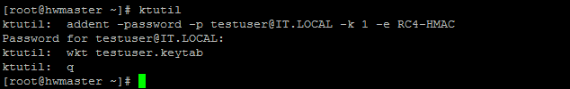

NOTE:

Password: testuser

1. Key tab will generate in /root directory

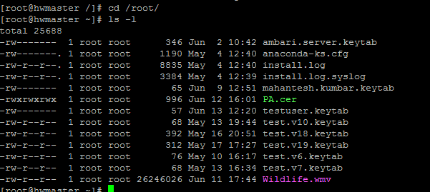

4 . copy “testuser.keytab” to /etc/security/keytabs/ folder

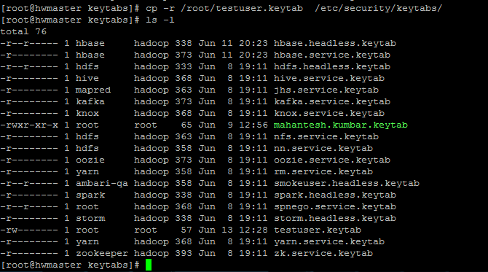

5. copy “testuser.keytab” to all nodes using scp command

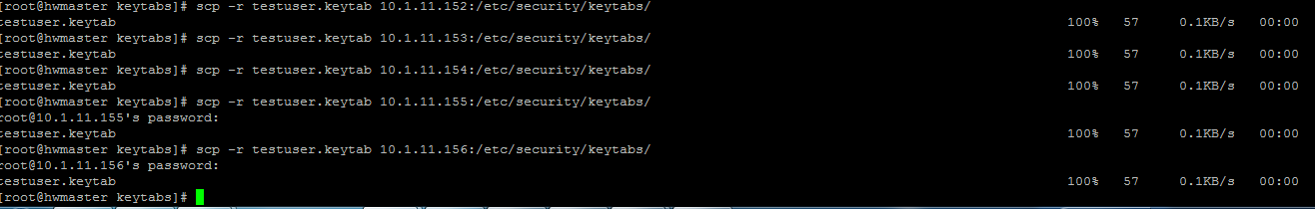

6. Create admin principal for testuser using below command

kadmin.local -q "addprinc testuser"

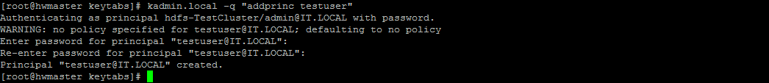

Note

Password: testuser

7) to check key tabs for testuser

klist -kt /etc/security/keytabs/testuser.keytab

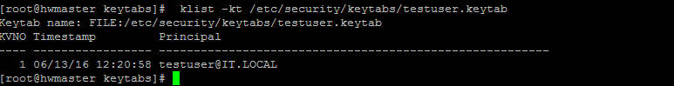

To verify

8) Login with testuser

Run below command

kinit -kt /etc/security/keytabs/testuser.keytab [testuser@IT.LOCAL](mailto:testuser@IT.LOCAL)